### A000-Eur-France-Le Grand Pressigny-Burin-Side Design-Middle Paleolithic-Mousterian phase-60,000-40,000 BP

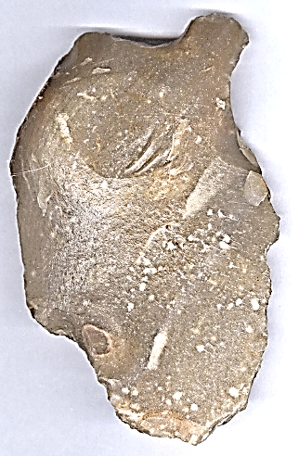 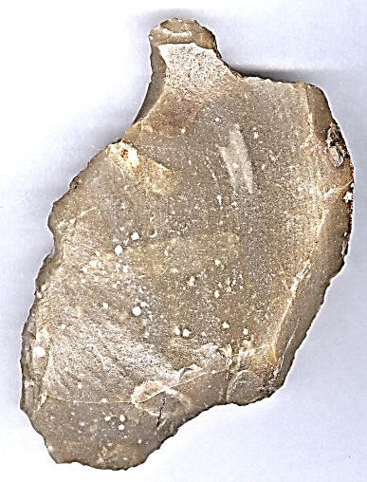

### Fig. 1. France-Le Grand Pressigny-Burin-Side Design-Middle Paleolithic-Mousterian phase-ca 60,000 BP- 40,000 BP

**Case no.: 1**

### **Accession Number:**

### **Formal Label:** France-Le Grand Pressigny-Burin-Side Design-Middle Paleolithic-Mousterian phase-ca 60,000 BP- 40,000 BP

**Display Description:** LeGrand Pressigny is the eponymous name of a flint industry known since 1863 for its flint which was used beginning in the Middle Paleolithic, Mousterian phase, ca 60,000 BP- 40,000 BP. Mining site F12 according to the catalogue of the museum in Bochum, 3rd edition ([Weisgerber](http://www.flintsource.net/biblio/littW.html" \l "Weisgerber1999a) *[et al.](http://www.flintsource.net/biblio/littW.html" \l "Weisgerber1999a)* [(eds.) 1999](http://www.flintsource.net/biblio/littW.html" \l "Weisgerber1999a)). This burin is an example of a tool made from Le Grand Pressigny flint by striking the core, and then manipulating the flake with a large, deep facette struck on its edge to produce the burin. This side design was used to create a force to slash rawhide.

**LC Classification:** GN776.22.F7

### **Date or Time Horizon:** 60,000-40,000 BP.

**Geographical Area:** Le Grand Pressigny, France.

**Map:**

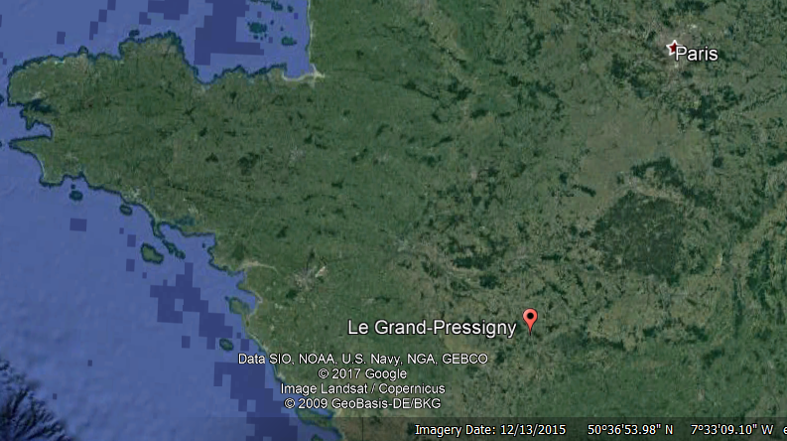 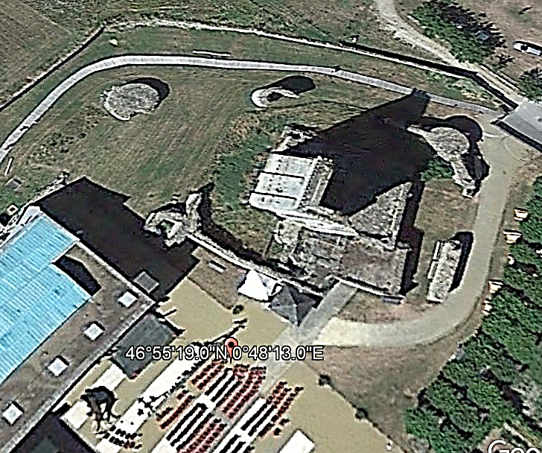

Fig. 2. Map of location of Le Grand Pressigny, France. Google Maps

Fig. 3. Showing location of the flint occurrence within the Le Grand Pressigny castle.

**GPS coordinates:** [46° 55’19”](https://translate.googleusercontent.com/translate_c?depth=1&hl=en&prev=search&rurl=translate.google.com&sl=fr&sp=nmt4&u=http://tools.wmflabs.org/geohack/geohack.php%3Flanguage%3Dfr%26pagename%3DMus%25C3%25A9e_de_la_Pr%25C3%25A9histoire_du_Grand-Pressigny%26params%3D46.921809_N_0.803508_E_type:landmark_region:FR&usg=ALkJrhgTi55y0QOKYbuJSjEaIs86gAUBfA) [,](https://translate.googleusercontent.com/translate_c?depth=1&hl=en&prev=search&rurl=translate.google.com&sl=fr&sp=nmt4&u=http://tools.wmflabs.org/geohack/geohack.php%3Flanguage%3Dfr%26pagename%3DMus%25C3%25A9e_de_la_Pr%25C3%25A9histoire_du_Grand-Pressigny%26params%3D46.921809_N_0.803508_E_type:landmark_region:FR&usg=ALkJrhgTi55y0QOKYbuJSjEaIs86gAUBfA) [0° 48'13"](https://translate.googleusercontent.com/translate_c?depth=1&hl=en&prev=search&rurl=translate.google.com&sl=fr&sp=nmt4&u=http://tools.wmflabs.org/geohack/geohack.php%3Flanguage%3Dfr%26pagename%3DMus%25C3%25A9e_de_la_Pr%25C3%25A9histoire_du_Grand-Pressigny%26params%3D46.921809_N_0.803508_E_type:landmark_region:FR&usg=ALkJrhgTi55y0QOKYbuJSjEaIs86gAUBfA). 46.920000: 0.806000E

**Medium:** Le Grand Pressigny Flint, Upper Cretaceous (Turonian) flint.

**Dimensions:**   
**Weight:**

**Condition:** original.

**Provenance:** from an old Belgian collection of Le Grand Pressigny flint tools.

**Discussion:** Le Grand Pressigny flint was mined during the Middle Paleolithic, Mousterian Phase, 60,000-40,000 BP by Homo neanderthalensis.

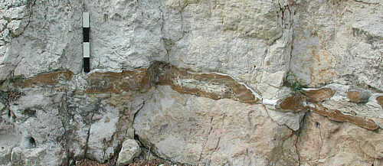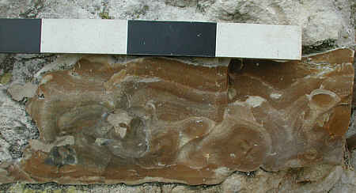  
Fig. 4. Upper Cretaceous (Turonian) flint occurs in lenses in the surrounding Turonian chalk matrix. After <http://www.flintsource.net/flint/F/presigbank.jpg>. Foto: Rengert Elburg, 2002.

Fig. 5. Detail of Upper Cretaceous flint lense. After <http://www.flintsource.net/flint/F/presigbank.jpg>..

Parietal art in the nearby Cave F. d’Achon was also the product of *Homo neanderthalensis*. The dating of this site to 60,000-40,000 BP provides further confirmation that the use of Le Pressigny Flint was the product of Homo neanderthalensis in the Mousterian Period.

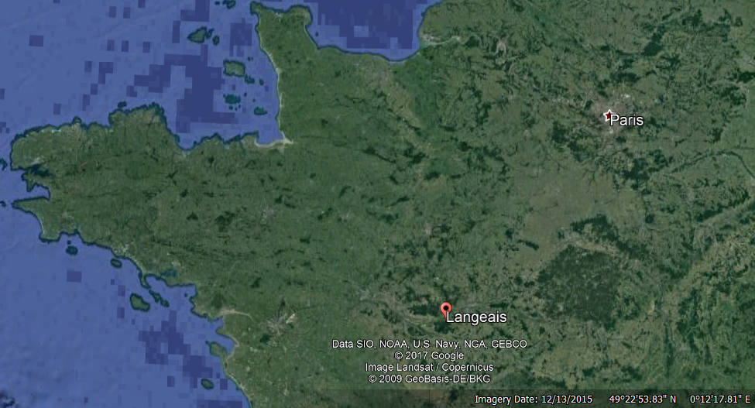. 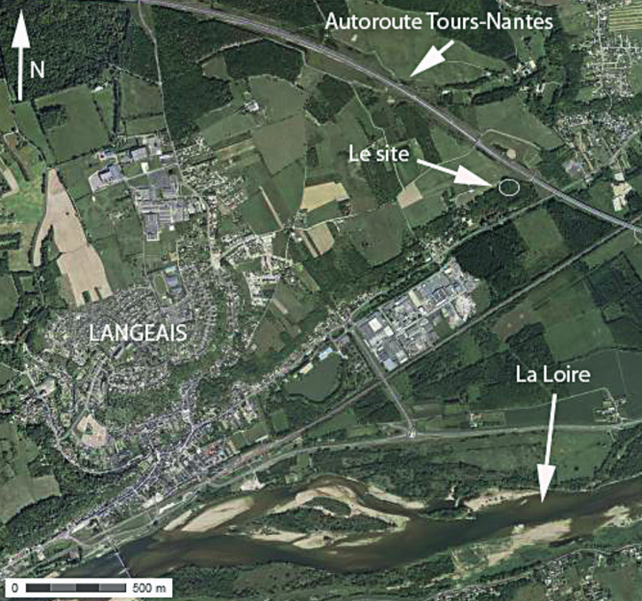

Fig. 6. Cave F. d’Achon in Langeais, Indre-et-Loire. Geographical location.

Fig. 7. Cave F. d’Achon in Langeais, Indre-et-Loire. Geographical location, detail. After http://journals.openedition.org/paleo/docannexe/image/3013/img-1.png

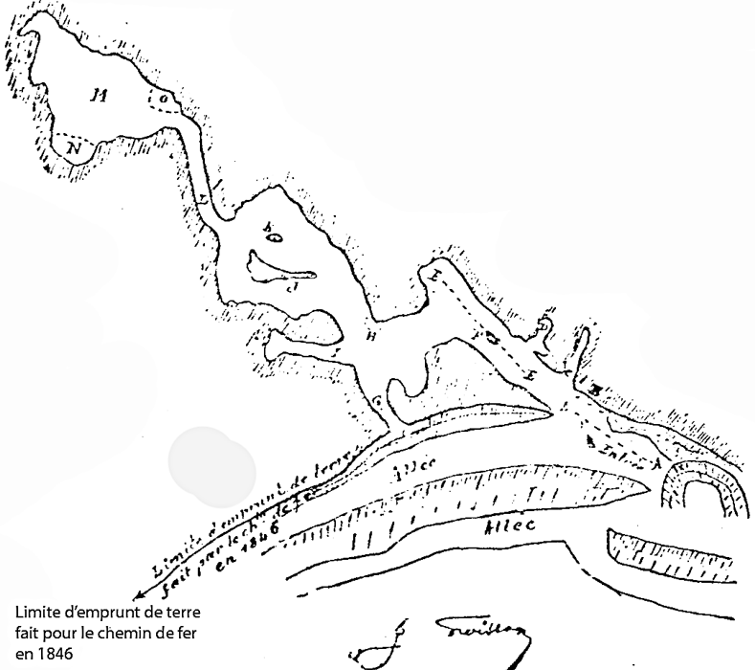 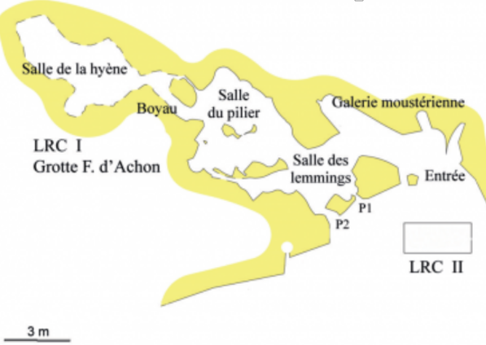

Fig. 8. Map of Cave F. d’Achon, drawn in 1912 by architect J. Froisson. The plan indicates clearly the limit of the removal of sediments extracted for the railway construction between Tours and Angers. After <http://journals.openedition.org/paleo/docannexe/image/3013/img-3-small580.png>

Fig. 9. Map of Cave F. d’Achon, Situation of two loci of the site.

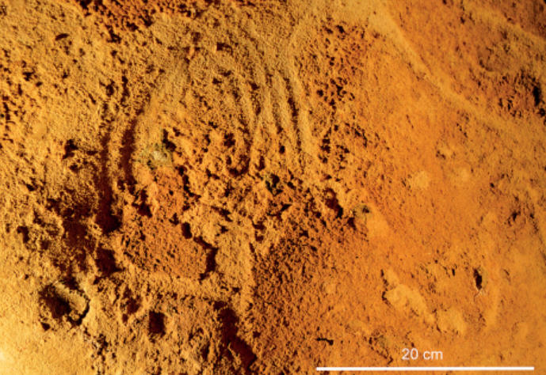 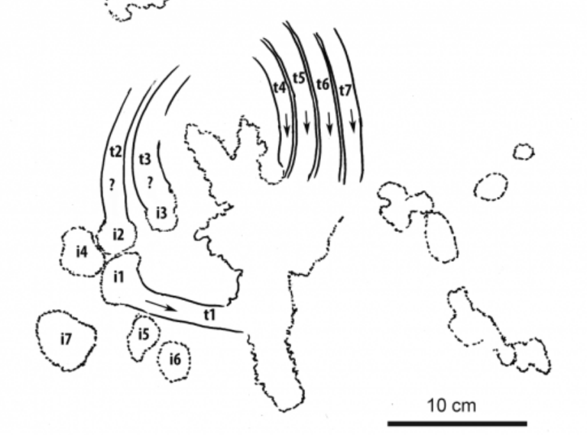

Fig. 10.  La Roche-Cotard I. Panel with circular form in « la salle du pilier. Foto: Rengert Elburg, 2002. ».http://journals.openedition.org/paleo/docannexe/image/3013/img-10-small580.png

Fig. 11. La Roche-Cotard I . Interpretative sketch of the panel with circular form in « la salle du pilier ».

http://journals.openedition.org/paleo/docannexe/image/3013/img-11-small580.png

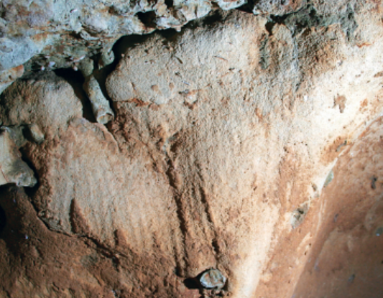 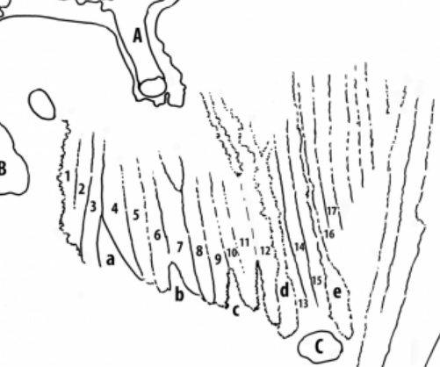

Fig. 12. La Roche-Cotard I. Foto: Rengert Elburg, 2002. Panel with circular form in « la salle du pilier ». After <http://journals.openedition.org/paleo/docannexe/image/3013/img-12-small580.png>

Fig. 13. Triangular panel. Interpretative sketch. After http://journals.openedition.org/paleo/docannexe/image/3013/img-15-small580.png

**References:**

Louboutin, C. 2011. Archeology of the Touraine. Paris: Éditions La Simarre.

Mallet, Nicole. 1992. *Grand-Pressigny: ses relations avec la civilisation Saône-Rhône*. [Argenton-sur-Creuse]: Amis du Musée de préhistoire du Grand-Pressigny. v.1. Texte -- v. 2. Planches.

Steenstrup, J. and John Lubbock. 1867. “On the Flint Implements Recently Discovered at Pressigny-le-Grand,” *Transactions of the Ethnological Society of London*, 5: 221-227.